

Signals Project Report

Tarek Zeyad Mohamed Rezk 52-20905

T-19

Project Description

* Import the libraries that (numpy, matplotlib and sounddevice).
* Setting the time to 3 seconds starting from 0 to 3 and 32\*1042 samples (linspace(0,3,32\*1024)).
* Array right containing frequencies of the 3rd octave notes.
* Array left containing frequencies of the 4rd octave notes.
* Intering the reqired frequencies for output sound.
* Array rT1 containing the notes time of the song of the right hand
* Array rT2 containing the notes timeof the song of the left
* u(t) a function to be able to use it directly In the for loop that loops on the 2 arrays summing all the resulting functions
* Plott the graph of t & x and playing the sound.

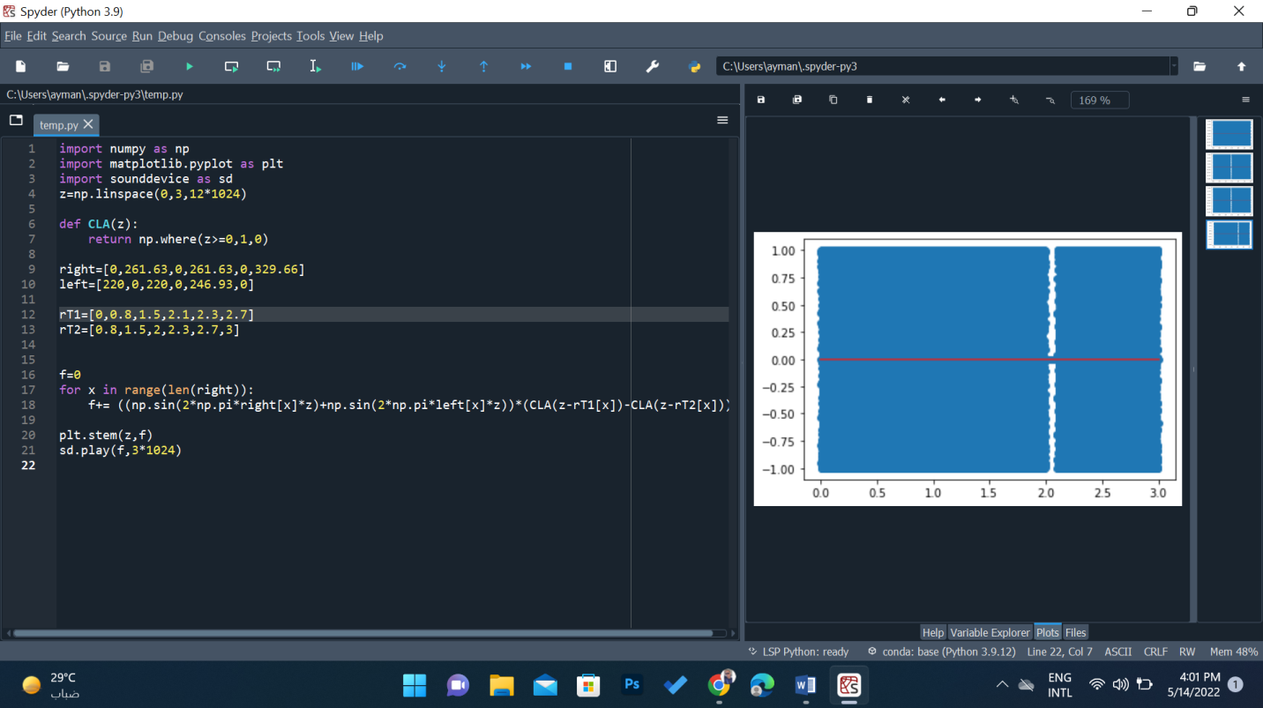

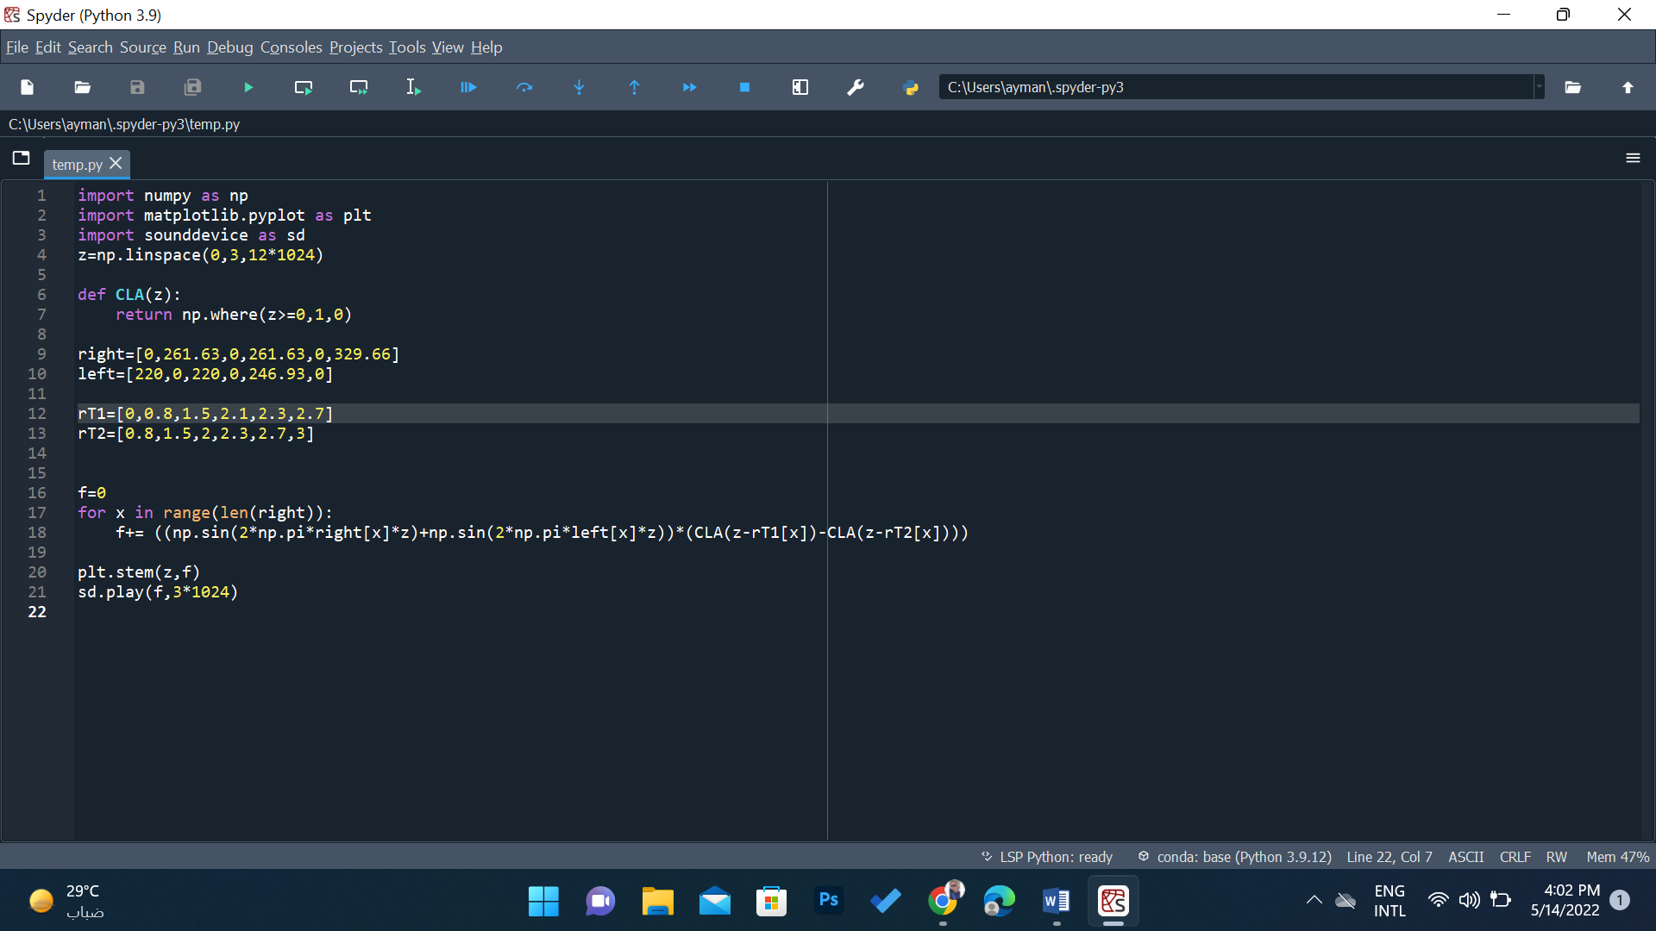

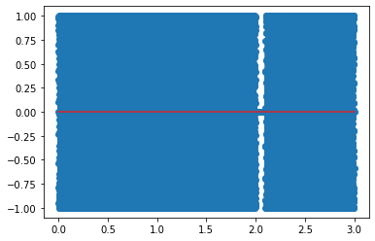

Project Description2

* Beside the imported libraries from milstone1 import fft from Scipy Setting k as frequency starting for 0 and end at 512 : k = np. linspace(0 , 512 , int(𝑁/2))
* Converting the single of time domain to frequency domain
* Generate two random frequency and generate the noise with is
* Adding the notice to the signal
* Converting the summed signal from time domain to frequency domain
* Getting the largest and the second largest value and rounding up them
* Remove the noise from the time domain
* Play the signal and check that it is not with noise
* Sd.plat (fill,3\*1024)

